**WADE SORE PROJECT**

## -social recommender-

# 

# Introduction

### Project Overview

This project aims to develop a sophisticated Web modular system designed to deliver personalized recommendations across a diverse range of interests such as people, events, places, and various other items. The core of this system is a dynamically constructed knowledge graph, expressed in RDF (Resource Description Framework), which is tailored to each user. This graph is built by analyzing data from multiple sources, primarily focusing on users' social media profiles.

### Objective

The primary objective of this system is to provide highly accurate, personalized recommendations by considering a myriad of user-specific features and properties. These can include professional skills, geographic location, technical preferences, demographic information, educational background, hobbies, and aversions. For example, the system could suggest members for an IT team based on their expertise in specific technologies, their location, and their preference for using open-source software.

### Target Users

The system is designed for a wide range of users who seek personalized recommendations - from individuals looking for event suggestions to businesses needing to assemble specialized teams. It offers a unique value proposition by catering to specific and diverse user requirements.

### Key Features

* Dynamic Knowledge Graph Construction: Utilizes RDF to build a user-centric knowledge graph from social media profiles and other data sources.
* Multi-Faceted Recommendation Logic: Considers a wide array of user attributes, such as professional skills, personal interests, and lifestyle preferences.
* Adaptive Learning: The system employs user feedback, reasoning, and machine learning techniques to continually refine and improve the recommendation accuracy.
* Accessibility via SPARQL Endpoint: Offers a versatile and standard query interface for accessing recommendations, facilitating easy integration with various applications.

### System Modules

The system comprises several interlinked modules, each responsible for a specific function:

* User Interface Service: Provides an interactive interface for users to receive recommendations and provide feedback.
* Data Ingestion and Profiling Service: Gathers and processes user data to create detailed profiles.
* Knowledge Graph Service: Builds and maintains the RDF-based knowledge graph.
* Recommendation Engine: Analyzes the knowledge graph to generate personalized recommendations.
* Feedback and Learning Module: Integrates user feedback into the system to enhance the recommendation process.

### Technical Highlights

* RDF and SPARQL Utilization: Leveraging RDF for constructing knowledge graphs and SPARQL for querying, ensuring data interoperability and standardization.
* Machine Learning Integration: Utilizing advanced machine learning algorithms to analyze data and adapt to user preferences.
* Modular Architecture: Ensuring scalability and maintainability through a service-oriented architecture.

# 

# Requirements

### Functional Requirements

* Data Ingestion:
  + Ability to ingest data from various sources, especially social media platforms.
  + Efficient extraction of relevant user data (demographics, interests, activities).
* Knowledge Graph Construction:
  + Capability to construct and maintain a knowledge graph using RDF.
  + Dynamic updating of the graph based on new or altered data.
* Recommendation Engine:
  + Development of an algorithm capable of making personalized recommendations based on the knowledge graph.
  + Inclusion of diverse criteria for recommendations, such as skills, location, preferences, and aversions.
* User Feedback Integration:
  + Functionality for users to provide feedback on recommendations.
  + Mechanism to incorporate feedback into the recommendation process, enhancing accuracy and relevance.
* SPARQL Endpoint:
  + Provision of a SPARQL endpoint for querying the knowledge graph.
  + Ensure robustness and security in data querying processes.

### Data and Privacy Requirements

* Data Privacy and Security:
  + Adherence to data protection laws (like GDPR) in handling user data.
  + Secure storage and transfer of sensitive information.
* Data Processing and Storage:
  + Efficient processing and storage of large volumes of data.
  + Scalable storage solutions to accommodate growing data needs.

### User Interface and Experience Requirements

* User Interface:
  + Development of a user-friendly web interface.
  + Responsive design for compatibility across various devices.
* Accessibility:
  + Compliance with accessibility standards to cater to all users.
  + Clear navigation and intuitive design for ease of use.

### Technical and Performance Requirements

* System Architecture:
  + Implementation of a modular, service-oriented architecture.
  + Scalability to handle increasing loads and data volumes.
* Performance:
  + High-performance algorithms for real-time data processing and recommendation generation.
  + Optimized database queries for efficient data retrieval.
* Integration and Extensibility:
  + Ability to integrate with various APIs and data sources.
  + Flexibility for future enhancements and integration of additional modules.

### Machine Learning and Analytics Requirements

* Machine Learning Integration:
  + Incorporation of machine learning algorithms for dynamic recommendation improvements.
  + Continuous learning from user interactions and feedback.
* Analytics:
  + Tools for monitoring and analyzing system performance and user engagement.
  + Data-driven insights to guide system enhancements.

# 

# Technologies

### Front-End Development (React)

* React.js: Main library for building the user interface.
* Redux: State management library, useful for managing global state across React components.
* React Router: For client-side routing within the React application.
* Axios or Fetch API: For making HTTP requests to backend services.
* Material-UI or Bootstrap (React Version): UI frameworks for React to design a responsive and attractive interface.
* Webpack and Babel: For bundling and transpiling the React code.
* ESLint and Prettier: Code linting and formatting tools.

### Back-End Development (Node.js)

* Node.js: JavaScript runtime environment for building the server-side of the application.
* Express.js: Web application framework for Node.js to handle HTTP requests.
* Mongoose: ODM (Object Data Modeling) library for MongoDB and Node.js.
* Passport.js: For implementing user authentication.
* Dotenv: To manage environment variables.
* Jest: For testing Node.js applications.
* Nodemon: Utility for automatically restarting Node.js server during development.

### Database (MongoDB) - Might not be GOOD #TODO

* MongoDB: NoSQL database for storing user data, profiles, and other relevant data.
* MongoDB Atlas: Cloud-based MongoDB service for database hosting.
* MongoDB Compass: GUI tools for managing MongoDB databases.

### Data Ingestion and Processing

* Node.js libraries for API integrations: For ingesting data from various sources, especially social media platforms.

### Knowledge Graph and RDF Handling

* Apache Jena or RDFLib (with Node.js binding): For handling RDF data and knowledge graph construction.
* SPARQL.js: SPARQL query library for Node.js.

### Machine Learning (For Recommendation Engine)

* TensorFlow.js or brain.js: JavaScript libraries for machine learning in Node.js.
* Python with ML libraries (optional): In case advanced machine learning processing is required, Python can be used in conjunction with Node.js.

### Miscellaneous

* Git and GitHub: For version control.
* Postman: For testing and interacting with APIs during development.

None of the technologies from below are used but are worth mentioning for future implementations.

### Deployment and Hosting

* Docker: For containerizing the application.
* Docker Compose: For orchestration and management of application containers.
* AWS, Azure, or Google Cloud Platform: For cloud hosting and services.

### Monitoring and Logging

* Prometheus and Grafana: For monitoring the performance of the application.
* Winston or Morgan: Logging libraries for Node.js.
* Sentry: For error tracking and monitoring.

# 

# 

# OpenAPI Specification

1. ReviewRecommendation

| openapi: 3.0.0 info:  title: Review Recommendation API  version: 1.0.0 servers:  - url: https://api.sore.com/v1 paths:  /reviewRecommendation:  post:  summary: Submit a review recommendation and receive a response  requestBody:  required: true  content:  application/json:  schema:  $ref: '#/components/schemas/ReviewRecommendationRequest'  responses:  '200':  description: Review recommendation response  content:  application/json:  schema:  $ref: '#/components/schemas/ReviewRecommendationResponse' components:  schemas:  ReviewRecommendationRequest:  type: object  required:  - recommendationId  - grade  properties:  recommendationId:  type: string  grade:  $ref: '#/components/schemas/Grade'  ReviewRecommendationResponse:  type: object  required:  - reviewId  properties:  reviewId:  type: string  Grade:  type: object  required:  - stars  properties:  stars:  type: number |
| --- |

1. ListRecommendations

| ListRecommendations openapi: 3.0.0 info:  title: List Recommendations API  version: 1.0.0 servers:  - url: https://api.sore.com/v1 paths:  /listRecommendations/{userId}:  get:  summary: List recommendations for a specific user with optional pagination  parameters:  - in: path  name: userId  required: true  schema:  type: string  description: The unique identifier for the user  - in: query  name: nextToken  schema:  type: string  description: Token for pagination to get the next set of recommendations  - in: query  name: limit  schema:  type: number  description: The number of recommendations to return in the response  responses:  '200':  description: A list of recommendations with optional pagination token  content:  application/json:  schema:  $ref: '#/components/schemas/ListRecommendationsResponse' components:  schemas:  ListRecommendationsResponse:  type: object  properties:  recommendations:  type: array  items:  $ref: '#/components/schemas/Recommendation'  nextToken:  type: string  nullable: true  Recommendation:  type: object  required:  - recommendationId  - recommendationContent  properties:  recommendationId:  type: string  recommendationContent:  $ref: '#/components/schemas/RecommendationContent'  RecommendationContent:  type: object  required:  - body  properties:  body:  type: string |
| --- |

1. ListHistory

| openapi: 3.0.0 info:  title: Recommendations Review History API  version: 1.0.0 servers:  - url: https://api.sore.com/v1 paths:  /listHistory/{userId}:  get:  summary: List history of user reviews with optional pagination  parameters:  - in: path  name: userId  required: true  schema:  type: string  description: The unique identifier for the user  - in: query  name: nextToken  schema:  type: string  description: Token for pagination to get the next set of reviews  - in: query  name: limit  schema:  type: number  description: The number of reviews to return in the response  responses:  '200':  description: A list of user reviews with optional pagination token  content:  application/json:  schema:  $ref: '#/components/schemas/ListHistoryResponse' components:  schemas:  Grade:  type: object  required:  - stars  properties:  stars:  type: number  ListHistoryResponse:  type: object  properties:  reviews:  type: array  items:  $ref: '#/components/schemas/RecommendationReview'  nextToken:  type: string  nullable: true  RecommendationReview:  type: object  required:  - reviewId  - reviewedAt  - grade  properties:  reviewId:  type: string  reviewedAt:  type: string  format: date-time  grade:  $ref: '#/components/schemas/Grade'  Paginator:  type: object  properties:  nextToken:  type: string  limit:  type: number |
| --- |

# C4 diagram

### Context diagram

Context Diagram in the C4 Model represents the highest level of abstraction of the system architecture. In the context of this web modular system for personalized recommendations, the diagram should illustrate the system's interactions with external entities (users and other systems)

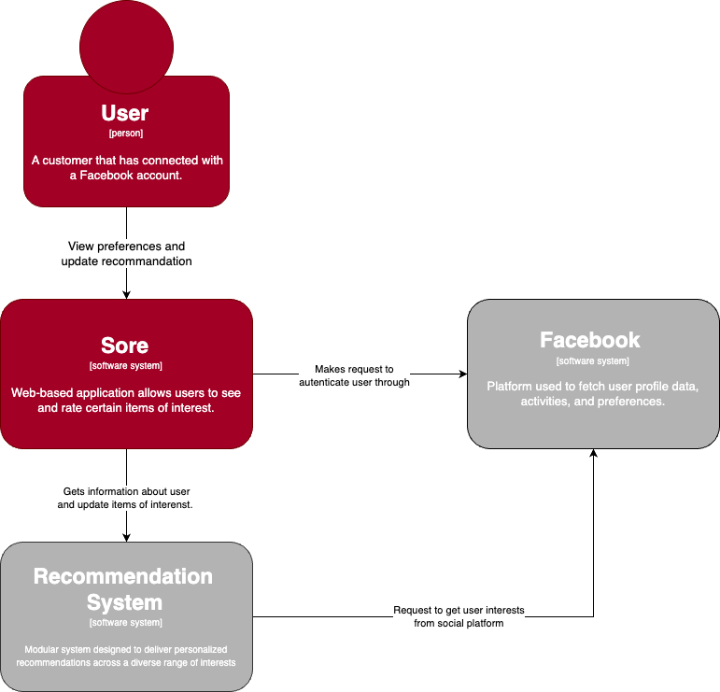

### Container diagram

In the C4 model, a Container diagram , delves into the system architecture by showing the high-level technology choices and how the application is divided into containers (applications, data stores, microservices, etc.). For this project the Container diagram should outline the major technological components and their interactions.

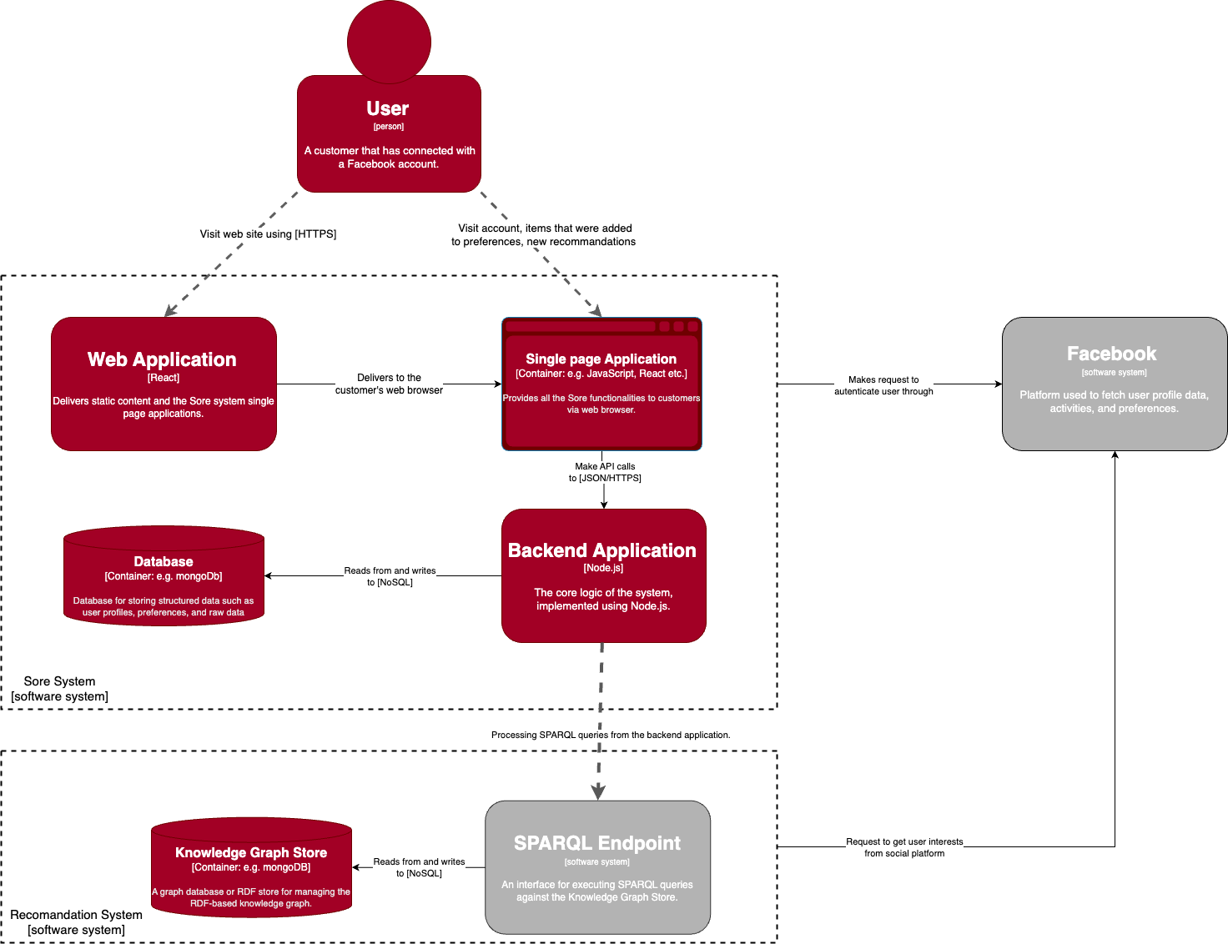

# 

# React-Based Front-End Architecture for User Interface Service:

### Mocks

* Login page  
  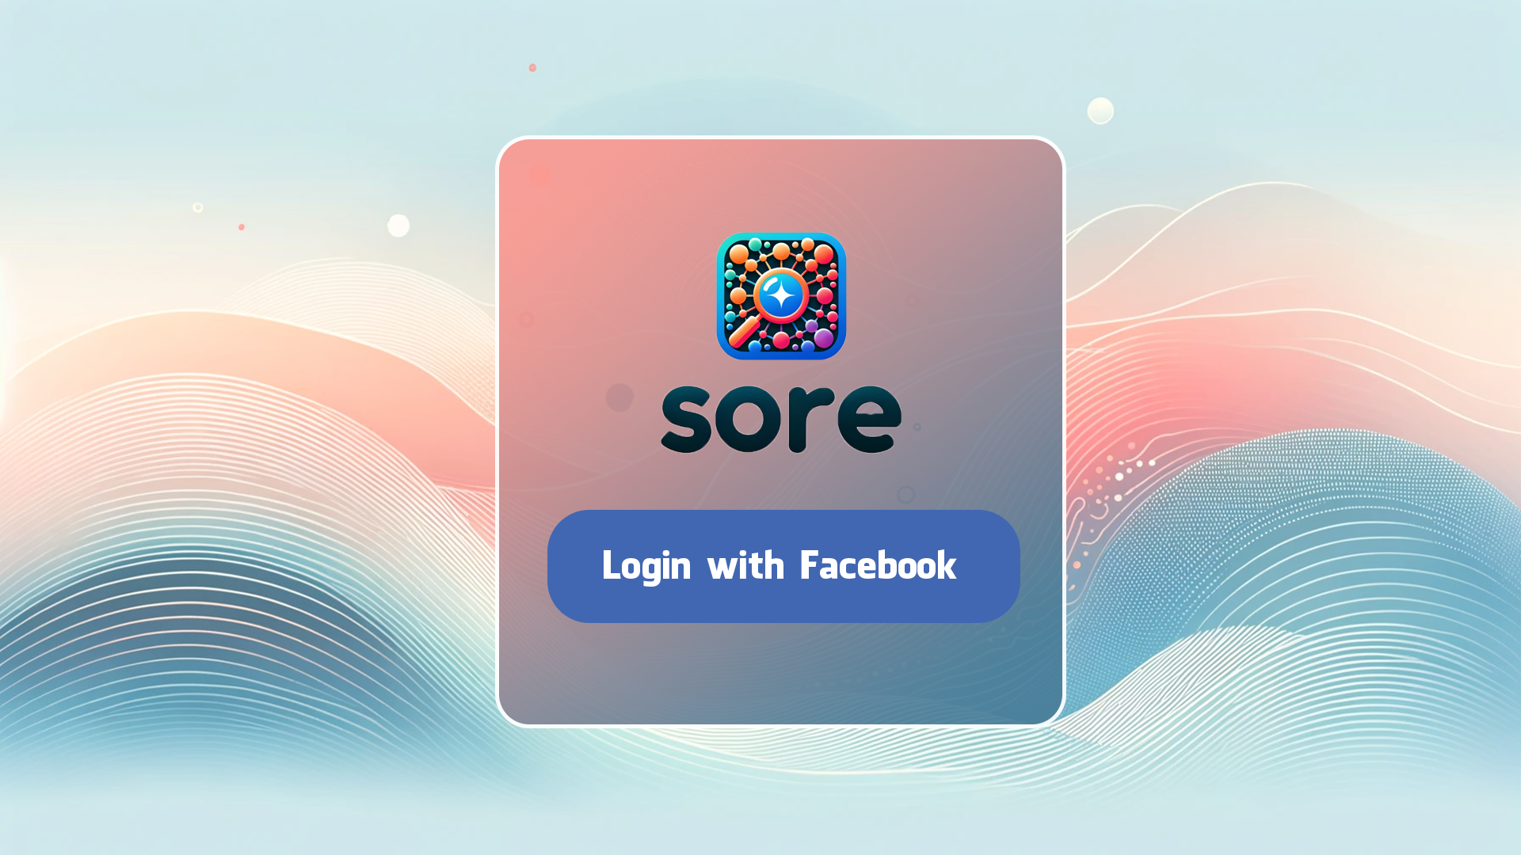
* Recommendations page  
  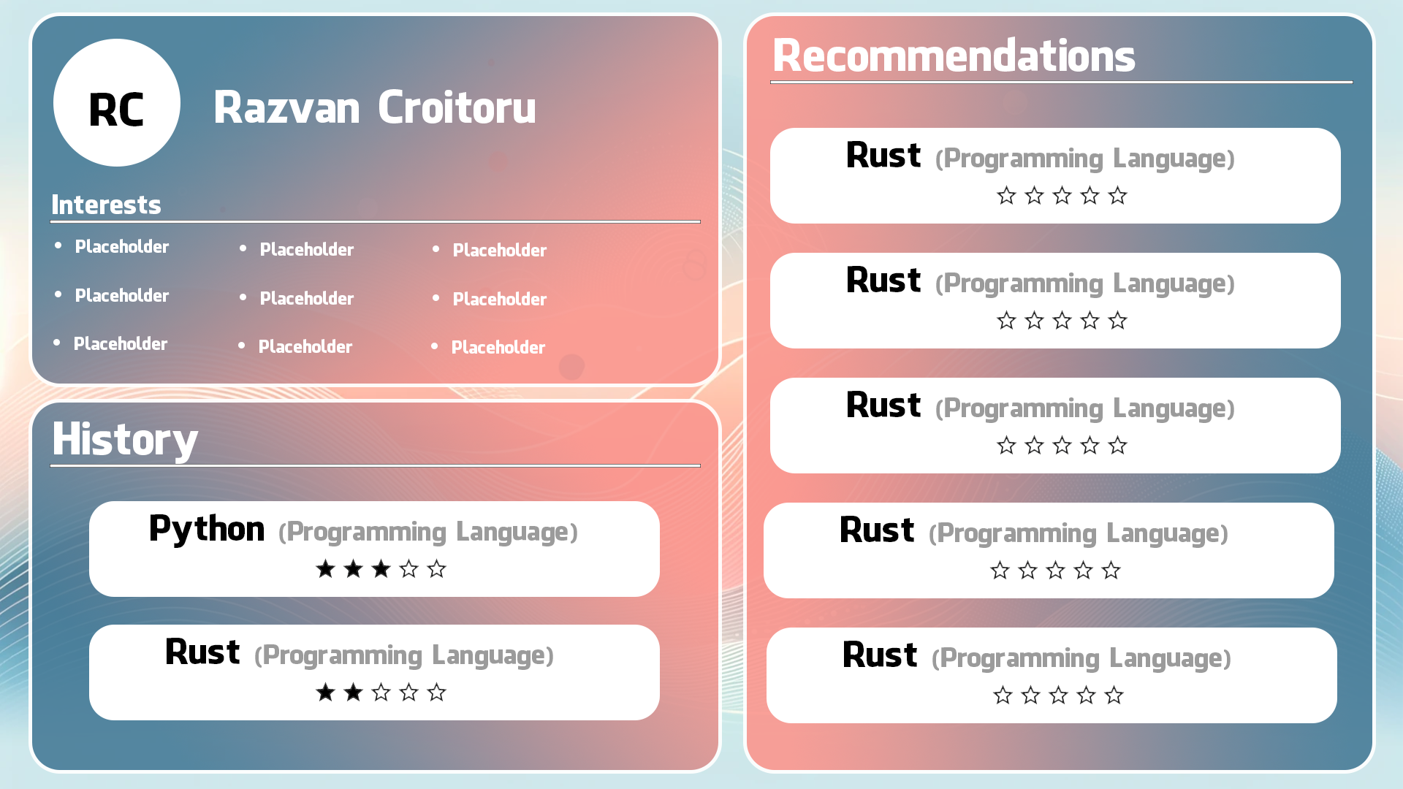

### Flow

* On login page, you can press login with facebook and you will be redirected to the recommendations page once you’ve successfully logged in
* On recommendations page, you have an overview of your profile with your most relevant interests. Those interests are updated based on the review of the recommendations.
* On the recommendations page, you are provided with a list of recommendations which you can grade using a star system. Once you grade a recommendation, it will be removed from the recommendations section and moved into the history section.
* On the recommendations page, you have a history of the recommendations you previously reviewed.

### Component Architecture

* Modular Components: Design UI as a collection of reusable React components (e.g., UserProfile, RecommendationsList, FeedbackForm).
* Stateful and Stateless Components: Use stateful components for dynamic data handling and stateless components for static UI elements.

### State Management

* Context API/Redux: Use Context API for simple state management or integrate Redux for more complex global state management.
* Immutable State Updates: Ensure state immutability for predictable UI changes and easier debugging.

### Routing

* React Router: Implement client-side routing with React Router to handle navigation within the application.
* Dynamic and Protected Routes: Use dynamic routing for user profiles and protected routes for authenticated areas.

### User Authentication and Authorization

* OAuth/OpenID Integration: Authentication and Authorization with Facebook OAuth
* Protected Component Access: Implement higher-order components or hooks to protect routes that require authentication.

### API Communication

* Axios/Fetch: Use Axios or Fetch API for handling API requests to backend services.
* Error Handling: Implement robust error handling for API responses.

### User Interface Design

* CSS-in-JS/SCSS: Use styling solutions like Styled Components or SCSS for styling.
* Responsive Design: Implement a responsive design using Flexbox, Grid, or frameworks like Bootstrap.

### Feedback and Interaction

* Event Handling: Utilize React’s synthetic event system for handling user interactions.
* Form Handling: Use controlled components for form inputs and validations.

### Performance Optimization

* Lazy Loading: Use React.lazy for component-level code splitting.
* Memoization: Use React.memo and useCallback to prevent unnecessary renders.

### Real-Time Data Handling

* WebSockets or Polling: Integrate real-time data updates using WebSockets or polling mechanisms.

### Accessibility

* ARIA Attributes: Ensure accessibility by using ARIA attributes and semantic HTML.
* Keyboard Navigation: Implement keyboard navigation support for all interactive elements.

### Internationalization

* Libraries: Use libraries like react-i18next for multi-language support.

### Testing

* Unit and Integration Testing: Use Jest and React Testing Library for unit and integration testing.
* End-to-End Testing: Implement end-to-end testing with tools like Cypress.

### Development Tools

* Create React App: Utilize Create React App for project scaffolding.
* ESLint, Prettier: Use ESLint for code quality and Prettier for code formatting.

### Documentation

* Component Documentation: Use tools like Storybook for documenting components.

### Integration with Backend Services

* Data Fetching: Implement hooks or higher-order components to fetch data from backend services (e.g., user data, recommendations).

### Deployment

* Build and Deployment: Configure build scripts for production deployment, consider using server-side rendering (SSR) solutions like Next.js for improved performance and SEO.

## Authentication and Authorization with Facebook OAuth

### Overview

This document outlines the process of integrating Facebook OAuth into our React-based web application for user authentication and authorization.

### Prerequisites

* A Facebook Developer account.
* A Facebook App with OAuth settings configured.
* Basic understanding of React and OAuth 2.0 flow.

### Dependencies

* react-oauth2-auth-code-flow or similar library for handling the OAuth flow.
* axios or fetch for API requests.

### Configuration

* Facebook App Setup:
  + Create a new app in Facebook Developer Console.
  + Configure OAuth settings, including redirect URIs.
  + Obtain the App ID and App Secret.
* Environment Variables:
  + Store Facebook App ID and App Secret in environment variables for security.

### Implementation Steps

* Creating the Login Component:
  + Develop a Login component with a "Login with Facebook" button.
  + Attach an event handler to initiate the OAuth process when clicked.
* OAuth Flow:
  + On button click, redirect users to the Facebook authorization endpoint with required parameters (client ID, redirect URI, scope, response type).
  + Handle the redirection back to your application upon successful authorization.
* Handling the Authorization Code:
  + Extract the authorization code from the URL parameters.
  + Exchange the authorization code for an access token using a backend endpoint to secure the App Secret.
* Fetching User Data:
  + Use the access token to fetch user profile information from Facebook’s API.
  + Implement necessary error handling for failed requests or denied access.
* Session Management:
  + Store the access token securely in the client (e.g., HTTP-only cookies).
  + Use the token for subsequent requests to your application’s backend.
* User Authorization:
  + Implement role-based access control based on user information.
  + Optionally, map Facebook user data to your application’s user model.

### Security Considerations

* Ensure secure storage and transmission of tokens.
* Implement CSRF protection for the OAuth flow.
* Validate tokens and user data received from Facebook.

### Error Handling

* Handle errors in the OAuth flow gracefully, such as access denial.
* Provide informative error messages to the user.

### Testing

* Unit tests for the Login component and OAuth logic.
* Integration tests for the entire authentication flow.

### Deployment

* Verify that the production redirect URI is correctly configured in the Facebook app settings.

### Technologies and Tools:

* Frameworks: React
* UI Libraries: Material-UI
* State Management: ex:Redux
* Authentication: Facebook Auth0
* API Communication: Fetch API
* Real-Time Communication: WebSockets
* Visualization Tools: D3.js

#### Notes

* Keep the documentation updated with changes in Facebook's OAuth implementation.
* Regularly review the security practices and update them as necessary.

# 

# Data Ingestion and Profiling Service

### Overview

This service is pivotal for collecting and processing user data from various sources, including social media profiles, and transforming it into a structured knowledge graph expressed in RDF (Resource Description Framework). This graph is utilized for recommending items of interest like people, events, and places, tailored to the specific user.

### Prerequisites

* Familiarity with RDF, SPARQL, and knowledge graphs.
* Experience with social media APIs and data processing.
* Proficiency in a programming language suitable for backend development (e.g., Python, Node.js).

### Dependencies

* Libraries for handling RDF data (e.g., Apache Jena for Java, RDFlib for Python).
* Social media API client libraries.
* Data processing and transformation libraries.

### Configuration

* API Credentials: Secure storage of API keys and access tokens for social media platforms.
* RDF Store Configuration: Setup and configuration of an RDF store or graph database.

### Implementation Steps

* API Integration:
  + Implement modules to fetch data from social media APIs.
  + Handle authentication and data retrieval securely.
* Data Extraction:
  + Extract relevant user data such as interests, activities, locations, and social interactions.
* Data Transformation:
  + Transform the raw data into a structured format.
  + Map the data to RDF triples, creating a standardized representation.
* Knowledge Graph Construction:
  + Build and maintain an RDF-based knowledge graph from transformed data.
  + Ensure the graph structure aligns with the system’s recommendation logic.
* User Profiling:
  + Develop user profiles within the knowledge graph, encapsulating various features like demographics, interests, and behavioral patterns.
* Data Enrichment:
  + Optionally, enrich user profiles with additional data sources for more comprehensive insights.
* Error Handling:
  + Robust error handling for API interactions and data processing.
  + Log and monitor errors for timely resolution.
* Data Privacy and Compliance:
  + Ensure compliance with data protection regulations (like GDPR).
  + Implement data anonymization and privacy-preserving techniques where necessary.

### Security Considerations

* Encrypt sensitive data during transit and storage.
* Regularly update and rotate API credentials.

# 

# Knowledge Graph Construction Service Documentation

### Overview

This service is responsible for building and maintaining a knowledge graph expressed in RDF (Resource Description Framework), which forms the basis for our recommendation system.

### Dependencies

* Node.js RDF Libraries: Libraries like rdf-ext, rdf-js, or others for handling RDF data in Node.js.
* MongoDB: For storing non-RDF data that supports the knowledge graph.
* Graph Database (Optional): Integration with a graph database like Neo4j, if a more complex graph structure is needed beyond MongoDB’s capabilities.

### System Architecture

* Data Ingestion: Fetch data from various sources, including social media APIs, using Node.js.
* RDF Conversion: Transform the ingested data into RDF triples.
* Graph Storage: Store the RDF data in a suitable graph database or MongoDB, depending on the complexity required.
* SPARQL Interface: Implement a SPARQL endpoint for querying the knowledge graph.

### Implementation Steps

#### 1. Data Ingestion Module

* Develop Node.js scripts or services to ingest data from predefined sources.
* Ensure efficient and secure data transfer to the processing module.

#### 2. RDF Data Transformation

* Utilize Node.js RDF libraries to convert raw data into RDF format.
* Define appropriate ontologies and vocabularies (e.g., FOAF, Schema.org) for the knowledge graph.

#### 3. Graph Database Integration (Optional)

* If using a graph database, set up integration with Node.js.
* Map and store RDF triples in the graph database, ensuring efficient storage and retrieval.

#### 4. MongoDB Integration

* Store auxiliary data that supports the knowledge graph in MongoDB.
* Design schemas in MongoDB for efficient querying and aggregation.

#### 5. SPARQL Endpoint Setup

* Implement a SPARQL query interface within the Node.js environment.
* Ensure the endpoint can handle complex queries and return results in a performant manner.

#### 6. Integration with Frontend (React)

* Develop APIs in Node.js to communicate with the React frontend.
* Ensure secure and efficient data flow between the frontend and the knowledge graph service.

### Security and Data Privacy

* Implement authentication and authorization for accessing the SPARQL endpoint.
* Ensure compliance with data privacy laws and best practices in handling user data.

### Testing and Validation

* Write unit and integration tests for each module, particularly focusing on RDF data transformation and SPARQL query processing.
* Validate the correctness of the RDF triples and the responses from the SPARQL endpoint.

# 

# Recommendation Engine Service

### Overview

The engine's primary function is to analyze user data and the knowledge graph to generate personalized recommendations.

### Dependencies

* Node.js: Core platform for backend service development.
* Machine Learning Libraries: Libraries like TensorFlow.js or brain.js for implementing recommendation algorithms in Node.js.
* MongoDB: Database to store user profiles and recommendation data.
* Mongoose: ODM (Object Document Mapping) tool for MongoDB and Node.js integration.

### System Architecture

* Data Processing: Extract and process user data and knowledge graph information using Node.js.
* Algorithm Implementation: Develop the recommendation algorithms in Node.js, utilizing machine learning libraries if necessary.
* Data Storage: Use MongoDB for storing and retrieving recommendation-related data.
* APIs for Frontend Communication: Develop APIs for the React frontend to display recommendations.

### Implementation Steps

#### 1. Data Preparation and Analysis

* Implement data processing scripts in Node.js to prepare the input data for the recommendation engine.
* Analyze the user data and knowledge graph information to identify key features for recommendations.

#### 2. Recommendation Algorithm Development

* Develop the recommendation logic using suitable algorithms (e.g., collaborative filtering, content-based filtering, or hybrid methods).
* Integrate machine learning libraries if advanced processing like predictive analytics is required.

#### 3. Integration with MongoDB

* Design MongoDB schemas to store user preferences, recommendation results, and feedback data efficiently.
* Implement Mongoose models and queries for accessing and updating recommendation data.

#### 4. API Development for Frontend

* Create RESTful APIs or GraphQL endpoints in Node.js for the frontend to fetch recommendations.
* Ensure secure and efficient data exchange between the backend and React frontend.

#### 5. User Feedback Mechanism

* Develop a system to capture user feedback on recommendations in the frontend.
* Implement logic in the backend to process feedback and refine the recommendation algorithm.

### Testing and Validation

* Conduct unit and integration tests for backend algorithms and API endpoints.
* Validate the accuracy and relevance of the recommendations through user testing or simulated scenarios.

# 

# Feedback and Learning Service

### Overview

This service plays a crucial role in enhancing the efficacy of our recommendation engine by incorporating user feedback.

### Dependencies

* Machine Learning Libraries (optional): Libraries like TensorFlow.js for analyzing feedback data.

### System Architecture

* Feedback Collection: Implementation of a feedback mechanism in the React frontend.
* Data Processing: Backend services in Node.js for processing and storing feedback.
* Learning Mechanism: Integration of learning algorithms to update the recommendation logic.
* MongoDB Storage: Database for storing user feedback and learning outputs.

### Implementation Steps

#### 1. Feedback Collection Module (Frontend)

* Develop interactive components in React for users to provide feedback on recommendations.
* Implement submission mechanisms to send feedback data to the backend.

#### 2. Feedback Processing (Backend)

* Create Node.js endpoints to receive and process user feedback.
* Store feedback data in MongoDB using appropriate data models.

#### 3. Feedback Analysis and Learning

* Analyze feedback data to identify patterns and insights using Node.js.
* If using machine learning, apply algorithms to learn from feedback and adjust recommendation criteria.

##### 4. MongoDB Integration

* Design and implement MongoDB schemas to efficiently store feedback and any new insights generated.
* Use Mongoose for object modeling and to manage interactions with the MongoDB database.

##### 5. Updating Recommendation Logic

* Develop mechanisms to incorporate learning outcomes into the recommendation engine.
* Ensure that the recommendation logic dynamically adapts based on user feedback.

### Testing and Validation

* Conduct unit tests for backend logic and frontend components.
* Perform integration tests to ensure the entire feedback loop functions seamlessly.

# 

# SPARQL Query Service

### Overview

# This document outlines the SPARQL Query Service implementation for our web application. This service is integral to the system, providing a mechanism to query the RDF-based knowledge graph. The SPARQL service enables sophisticated querying capabilities for our application's recommendation engine.

### Dependencies

### Node.js SPARQL Libraries: Libraries like sparql-client-2 for SPARQL querying within Node.js.

# React: For developing frontend interfaces for query input and result visualization.

# MongoDB and Mongoose: For handling data that complements the RDF store.

# RDF Store or Graph Database: For storing RDF data and processing SPARQL queries.

### System Architecture

# SPARQL Endpoint: A Node.js-based server endpoint to process SPARQL queries.

# Frontend Query Interface: React components for users to input and manage SPARQL queries.

# Backend Query Processing: Node.js logic to handle, execute, and respond to SPARQL queries.

# MongoDB Integration: Database setup for storing and retrieving non-RDF data related to the queries.

### Implementation Steps

#### 1. Frontend Query Interface (React)

# Develop user-friendly components in React for query input and visualization of query results.

# Implement features for saving, editing, and re-running past queries.

#### 2. SPARQL Endpoint Setup (Node.js)

# Create a Node.js server endpoint to receive and process SPARQL queries.

# Integrate a SPARQL client library to facilitate query execution against the RDF store.

#### 

#### 3. Query Processing and Response

# Develop logic in Node.js to parse, validate, and execute SPARQL queries.

# Implement efficient handling of query responses and error messages.

#### 4. MongoDB Integration

# Utilize MongoDB for storing user query history, preferences, and other metadata.

# Design appropriate schemas and models using Mongoose for efficient data retrieval and storage.

### Security and Compliance

# Implement security measures to protect the SPARQL endpoint, including authentication and rate limiting.

# Ensure safe handling of user-generated queries to prevent injection attacks or other vulnerabilities.

# 

# 

# Database and Storage

# This document outlines the setup and management of the Database and Storage for our web application. This service is designed to efficiently store and manage various types of data, including user profiles, raw data, and the knowledge graph. The system utilizes MongoDB, a NoSQL database, for handling structured data and potentially integrates a graph database for managing RDF data.

### Dependencies

* MongoDB: Primary database for storing structured data like user profiles and raw data.
* Graph Database: An additional database (like Neo4j or Apache Jena) for managing RDF data.
* Mongoose: ODM library for MongoDB to simplify data handling in Node.js.
* Graph Database Connector: Depending on the chosen graph database, a relevant connector or library for Node.js.

### System Architecture

* MongoDB Storage: For structured data such as user profiles and raw input data.
* Graph Database Integration: For storing and querying RDF data related to the knowledge graph.
* Backend Data Management: Node.js services and APIs for data manipulation and retrieval.
* Frontend Data Interaction: React components for data display and user interaction

### Implementation Steps

#### 1. MongoDB Setup

# Define and create MongoDB schemas and collections for user profiles and raw data.

# Implement indexing strategies for performance optimization.

#### 2. Graph Database Integration

# Select an appropriate graph database for RDF data storage.

# Establish connectivity between the graph database and the Node.js backend.

#### 3. Data Modeling and Schema Design

# Design data models that efficiently capture the relationships and entities within user profiles and the knowledge graph.

# Ensure the models align with application requirements and data querying needs.

#### 4. Backend Integration (Node.js)

# Develop Node.js APIs for CRUD (Create, Read, Update, Delete) operations on MongoDB.

# Implement additional endpoints for handling RDF data queries and manipulations in the graph database.

#### 5. Frontend Integration (React)

# Create React components to display and interact with data stored in MongoDB and the graph database.

# Ensure secure and efficient data communication between the frontend and backend.

#### 6. Data Security and Integrity

# Implement security measures for data protection, including encryption and access control.

# Ensure data validation and consistency across both databases.

#### 7. Backup and Recovery Strategies

# Develop backup mechanisms for both MongoDB and the graph database.

# Plan and implement a recovery process for data restoration in case of data loss.

# 

# Interactions Among Services